

**CAPSTONE PROJECT REPORT**

**Report 4 – Software Design Document**

– Thủ Đức, November 202 –

**Table of Contents**

I. Project Report **5**

1. Status Report 5

2. Team Involvements 5

3. Issues/Suggestions 5

II. Software Design Document **6**

1. Overall Description 6

1.1 Assumptions 6

1.2 Design Constraints 6

1.3 Technology Suggestion 6

2. System Architecture Design 7

2.1 Overall Architecture 7

2.2 System Architecture 7

2.3 Package Diagram 7

3. System Detailed Design 8

3.1 Authentication 9

a. Class Diagram 9

b. Class Specification 9

b1. UserController 9

b2. User 9

b3. Roles 10

c. Sequence Diagram(s) 11

3.2 Manage User 11

a. Class Diagram 11

b. Class Specification 11

b1. UserController 11

b2. User 12

b3. Roles 12

c. Sequence Diagram(s) 13

3.3 Manage Test Case 13

a. Class Diagram 13

b. Class Specification 13

b1. UserController 13

b2. User 14

b3. Roles 14

c. Sequence Diagram(s) 15

3.4 Manage Test Run 15

a. Class Diagram 15

b. Class Specification 15

b1. UserController 15

b2. User 15

b3. Roles 16

c. Sequence Diagram(s) 17

3.5 Manage Test Plan 17

a. Class Diagram 17

b. Class Specification 17

b1. UserController 17

b2. User 17

b3. Roles 18

c. Sequence Diagram(s) 19

3.6 Manage Milestones 19

a. Class Diagram 19

b. Class Specification 19

b1. UserController 19

b2. User 19

b3. Roles 20

c. Sequence Diagram(s) 20

3.7 Manage Report 20

a. Class Diagram 20

b. Class Specification 20

b1. UserController 20

b2. User 21

b3. Roles 21

c. Sequence Diagram(s) 22

3.8 Manage Project 22

a. Class Diagram 22

b. Class Specification 22

b1. UserController 22

b2. User 23

b3. Roles 23

c. Sequence Diagram(s) 24

4. Data & Database Design 24

4.1 Database Design 24

a. User 26

b. Role 26

c. Project Member 26

d. Priorities 26

e. Milestone 27

f. Reports 27

g. Section 27

h. Test Case 28

i. Test Run 28

j. Test Plan 29

k. Status 29

4.2 Data File Design 29

# I. Project Report

## 1. Status Report

| **#** | **Work Item** | **Status** | **Notes (Work Item in Details)** |
| --- | --- | --- | --- |
| 1 |  | Pending |  |
| 2 |  | In Progress |  |
| 3 |  | Completed |  |

## 2. Team Involvements

| **#** | **Task** | **Member** | **Notes (Task Details, etc.)** |
| --- | --- | --- | --- |
| 1 |  | KienNT |  |
| 2 |  | TuanTV |  |
| 3 |  | AnhLM |  |

## 3. Issues/Suggestions

| **#** | **Issue** | **Status** | **Notes (Solution, Suggestion, etc.)** |
| --- | --- | --- | --- |
| 1 |  | Pending |  |
| 2 |  | In Progress |  |
| 3 |  | Completed |  |

# II. Software Design Document

## 1. Overall Description

### 1.1 Assumptions

* Internet connection: Cable, Wifi
* Operation system: Windows 10
* Computer processor: Intel Core I3
* Computer memory: 4GB or more
* Web browser: Chrome, IE
* IDE: Visual Studio, Visual Studio Code
* DBMS: SQL Server 2019
* Modeling: Draw.io
* Source control: Git on IDE

### 1.2 Design Constraints

* Internet connection:
  + Cable
  + Wi-fi (50Mbps or more)
* Opera system:
  + Windows 10
* Computer processor: Intel core i3
* Computer memory: 4GB or more
* Web browser:
  + Chrome
  + IE (version 11 or more)
* IDE: Visual studio 2019, Visual studio code
* DBMS: SQL Server 2019
* Modeling: Draw.io
* Source control: Git on IDE
  + GitHub

### 1.3 Technology Suggestion

## 2. System Architecture Design

### 2.1 Overall Architecture

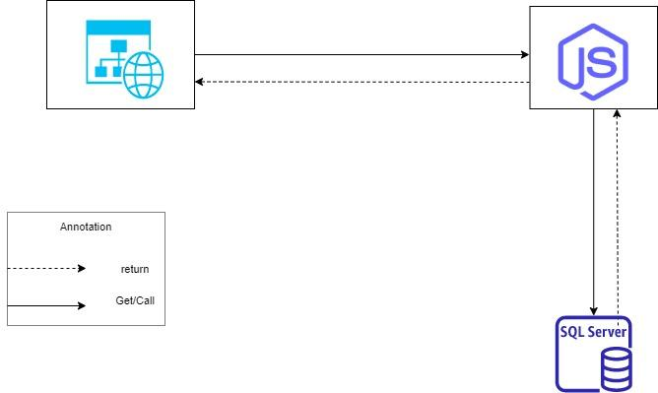

### 2.2 System Architecture

*[Select suitable architecture patterns for sub-systems. The content of this section include the overall diagram and the explanation for each of the diagram components]. For example: with the layer pattern, we need to provide the description for each of the layers and the relationship among the layers]*

### 2.3 Package Diagram

*[Provide the package diagram for each sub-system. The content of this section include the overall package diagram(s) and the explanation for each package. Please see the sample and description table format below]*

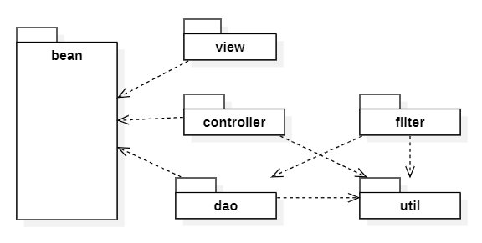

| **No** | **Package** | **Description** |
| --- | --- | --- |
| 01 | <Package name> | <Description of the package> |
| 02 |  |  |

## 3. System Detailed Design

### 3.1 Authentication

#### a. Class Diagram

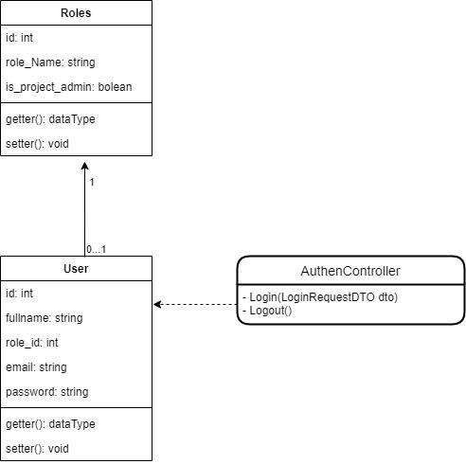

#### b. Class Specification

##### b1. AuthenController

*[Provide the detailed description for the class methods]*

| **No** | **Method** | **Description** |
| --- | --- | --- |
| 01 | Login | * Allow User to login to TMS with following field: + Email: String, required + Password: String, required |
| 02 | Logout | * Allow User logout of TMS |

##### b2. User

| **No** | **Attribute** | **Modify and type** | **Description** |
| --- | --- | --- | --- |
| 01 | id | private int | Unique identifier of a role |
| 02 | fullname | private string | Name of a user |
| 03 | email | private string | Email of a user |
| 04 | password | private string | Password of a user |

| **No** | **Method** | **Description** |
| --- | --- | --- |
| 01 | getter() | Get attribute value |
| 02 | setter() | Set attribute value |

##### b3. Roles

| **No** | **Attribute** | **Modify and type** | **Description** |
| --- | --- | --- | --- |
| 01 | id | private int | Unique identifier of a user |
| 02 | role_Name | private string | Name of a role |
| 03 | is_project_admin | private bool | Attribute representing whether the admin or not |

| **No** | **Method** | **Description** |
| --- | --- | --- |
| 01 | getter() | Get attribute value |
| 02 | setter() | Set attribute value |

#### c. Sequence Diagram(s)

### 3.2 Manage User

#### a. Class Diagram

#### b. Class Specification

##### b1. UserController

| **No** | **Method** | **Description** |
| --- | --- | --- |
| 01 | Login | * Allow User to login to TMS with following field: + Email: String, required + Password: String, required |
| 02 | Logout | * Allow User logout of TMS |

##### b2. User

| **No** | **Attribute** | **Modify and type** | **Description** |
| --- | --- | --- | --- |
| 01 | id | private int | Unique identifier of a role |
| 02 | fullname | private string | Name of a user |
| 03 | email | private string | Email of a user |
| 04 | password | private string | Password of a user |

| **No** | **Method** | **Description** |
| --- | --- | --- |
| 01 | getter() | Get attribute value |
| 02 | setter() | Set attribute value |

##### b3. Roles

| **No** | **Attribute** | **Modify and type** | **Description** |
| --- | --- | --- | --- |
| 01 | id | private int | Unique identifier of a user |
| 02 | role_Name | private string | Name of a role |
| 03 | is_project_admin | private bool | Attribute representing whether the admin or not |

| **No** | **Method** | **Description** |
| --- | --- | --- |
| 01 | getter() | Get attribute value |
| 02 | setter() | Set attribute value |

#### c. Sequence Diagram(s)

### 3.3 Manage Test Case

#### a. Class Diagram

#### b. Class Specification

##### b1. CaseController

| **No** | **Method** | **Description** |
| --- | --- | --- |
| 01 | Login | * Allow User to login to TMS with following field: + Email: String, required + Password: String, required |
| 02 | Logout | * Allow User logout of TMS |

##### b2. User

| **No** | **Attribute** | **Modify and type** | **Description** |
| --- | --- | --- | --- |
| 01 | id | private int | Unique identifier of a role |
| 02 | fullname | private string | Name of a user |
| 03 | email | private string | Email of a user |
| 04 | password | private string | Password of a user |

| **No** | **Method** | **Description** |
| --- | --- | --- |
| 01 | getter() | Get attribute value |
| 02 | setter() | Set attribute value |

##### b3. Roles

| **No** | **Attribute** | **Modify and type** | **Description** |
| --- | --- | --- | --- |
| 01 | id | private int | Unique identifier of a user |
| 02 | role_Name | private string | Name of a role |
| 03 | is_project_admin | private bool | Attribute representing whether the admin or not |

| **No** | **Method** | **Description** |
| --- | --- | --- |
| 01 | getter() | Get attribute value |
| 02 | setter() | Set attribute value |

#### c. Sequence Diagram(s)

### 3.4 Manage Test Run

#### a. Class Diagram

#### b. Class Specification

##### b1. RunController

| **No** | **Method** | **Description** |
| --- | --- | --- |
| 01 | Login | * Allow User to login to TMS with following field: + Email: String, required + Password: String, required |
| 02 | Logout | * Allow User logout of TMS |

##### b2. User

| **No** | **Attribute** | **Modify and type** | **Description** |
| --- | --- | --- | --- |
| 01 | id | private int | Unique identifier of a role |
| 02 | fullname | private string | Name of a user |
| 03 | email | private string | Email of a user |
| 04 | password | private string | Password of a user |

| **No** | **Method** | **Description** |
| --- | --- | --- |
| 01 | getter() | Get attribute value |
| 02 | setter() | Set attribute value |

##### b3. Roles

| **No** | **Attribute** | **Modify and type** | **Description** |
| --- | --- | --- | --- |
| 01 | id | private int | Unique identifier of a user |
| 02 | role_Name | private string | Name of a role |
| 03 | is_project_admin | private bool | Attribute representing whether the admin or not |

| **No** | **Method** | **Description** |
| --- | --- | --- |
| 01 | getter() | Get attribute value |
| 02 | setter() | Set attribute value |

#### c. Sequence Diagram(s)

### 3.5 Manage Test Plan

#### a. Class Diagram

#### b. Class Specification

##### b1. PlanController

| **No** | **Method** | **Description** |
| --- | --- | --- |
| 01 | Login | * Allow User to login to TMS with following field: + Email: String, required + Password: String, required |
| 02 | Logout | * Allow User logout of TMS |

##### b2. User

| **No** | **Attribute** | **Modify and type** | **Description** |
| --- | --- | --- | --- |
| 01 | id | private int | Unique identifier of a role |
| 02 | fullname | private string | Name of a user |
| 03 | email | private string | Email of a user |
| 04 | password | private string | Password of a user |

| **No** | **Method** | **Description** |
| --- | --- | --- |
| 01 | getter() | Get attribute value |
| 02 | setter() | Set attribute value |

##### b3. Roles

| **No** | **Attribute** | **Modify and type** | **Description** |
| --- | --- | --- | --- |
| 01 | id | private int | Unique identifier of a user |
| 02 | role_Name | private string | Name of a role |
| 03 | is_project_admin | private bool | Attribute representing whether the admin or not |

| **No** | **Method** | **Description** |
| --- | --- | --- |
| 01 | getter() | Get attribute value |
| 02 | setter() | Set attribute value |

#### c. Sequence Diagram(s)

### 3.6 Manage Milestones

#### a. Class Diagram

#### b. Class Specification

##### b1. MilestoneController

| **No** | **Method** | **Description** |
| --- | --- | --- |
| 01 | Login | * Allow User to login to TMS with following field: + Email: String, required + Password: String, required |
| 02 | Logout | * Allow User logout of TMS |

##### b2. User

| **No** | **Attribute** | **Modify and type** | **Description** |
| --- | --- | --- | --- |
| 01 | id | private int | Unique identifier of a role |
| 02 | fullname | private string | Name of a user |
| 03 | email | private string | Email of a user |
| 04 | password | private string | Password of a user |

| **No** | **Method** | **Description** |
| --- | --- | --- |
| 01 | getter() | Get attribute value |
| 02 | setter() | Set attribute value |

##### b3. Roles

| **No** | **Attribute** | **Modify and type** | **Description** |
| --- | --- | --- | --- |
| 01 | id | private int | Unique identifier of a user |
| 02 | role_Name | private string | Name of a role |
| 03 | is_project_admin | private bool | Attribute representing whether the admin or not |

| **No** | **Method** | **Description** |
| --- | --- | --- |
| 01 | getter() | Get attribute value |
| 02 | setter() | Set attribute value |

#### c. Sequence Diagram(s)

### 3.7 Manage Report

#### a. Class Diagram

#### b. Class Specification

##### b1. ReportController

| **No** | **Method** | **Description** |
| --- | --- | --- |
| 01 | Login | * Allow User to login to TMS with following field: + Email: String, required + Password: String, required |
| 02 | Logout | * Allow User logout of TMS |

##### b2. User

| **No** | **Attribute** | **Modify and type** | **Description** |
| --- | --- | --- | --- |
| 01 | id | private int | Unique identifier of a role |
| 02 | fullname | private string | Name of a user |
| 03 | email | private string | Email of a user |
| 04 | password | private string | Password of a user |

| **No** | **Method** | **Description** |
| --- | --- | --- |
| 01 | getter() | Get attribute value |
| 02 | setter() | Set attribute value |

##### b3. Roles

| **No** | **Attribute** | **Modify and type** | **Description** |
| --- | --- | --- | --- |
| 01 | id | private int | Unique identifier of a user |
| 02 | role_Name | private string | Name of a role |
| 03 | is_project_admin | private bool | Attribute representing whether the admin or not |

| **No** | **Method** | **Description** |
| --- | --- | --- |
| 01 | getter() | Get attribute value |
| 02 | setter() | Set attribute value |

#### c. Sequence Diagram(s)

### 3.8 Manage Project

#### a. Class Diagram

#### b. Class Specification

##### b1. ProjectController

| **No** | **Method** | **Description** |
| --- | --- | --- |
| 01 | Login | * Allow User to login to TMS with following field: + Email: String, required + Password: String, required |
| 02 | Logout | * Allow User logout of TMS |

##### b2. User

| **No** | **Attribute** | **Modify and type** | **Description** |
| --- | --- | --- | --- |
| 01 | id | private int | Unique identifier of a role |
| 02 | fullname | private string | Name of a user |
| 03 | email | private string | Email of a user |
| 04 | password | private string | Password of a user |

| **No** | **Method** | **Description** |
| --- | --- | --- |
| 01 | getter() | Get attribute value |
| 02 | setter() | Set attribute value |

##### b3. Roles

| **No** | **Attribute** | **Modify and type** | **Description** |
| --- | --- | --- | --- |
| 01 | id | private int | Unique identifier of a user |
| 02 | role_Name | private string | Name of a role |
| 03 | is_project_admin | private bool | Attribute representing whether the admin or not |

| **No** | **Method** | **Description** |
| --- | --- | --- |
| 01 | getter() | Get attribute value |
| 02 | setter() | Set attribute value |

#### c. Sequence Diagram(s)

## 4. Data & Database Design

### 4.1 Database Design

*[Provide the tables relationship like example below]*

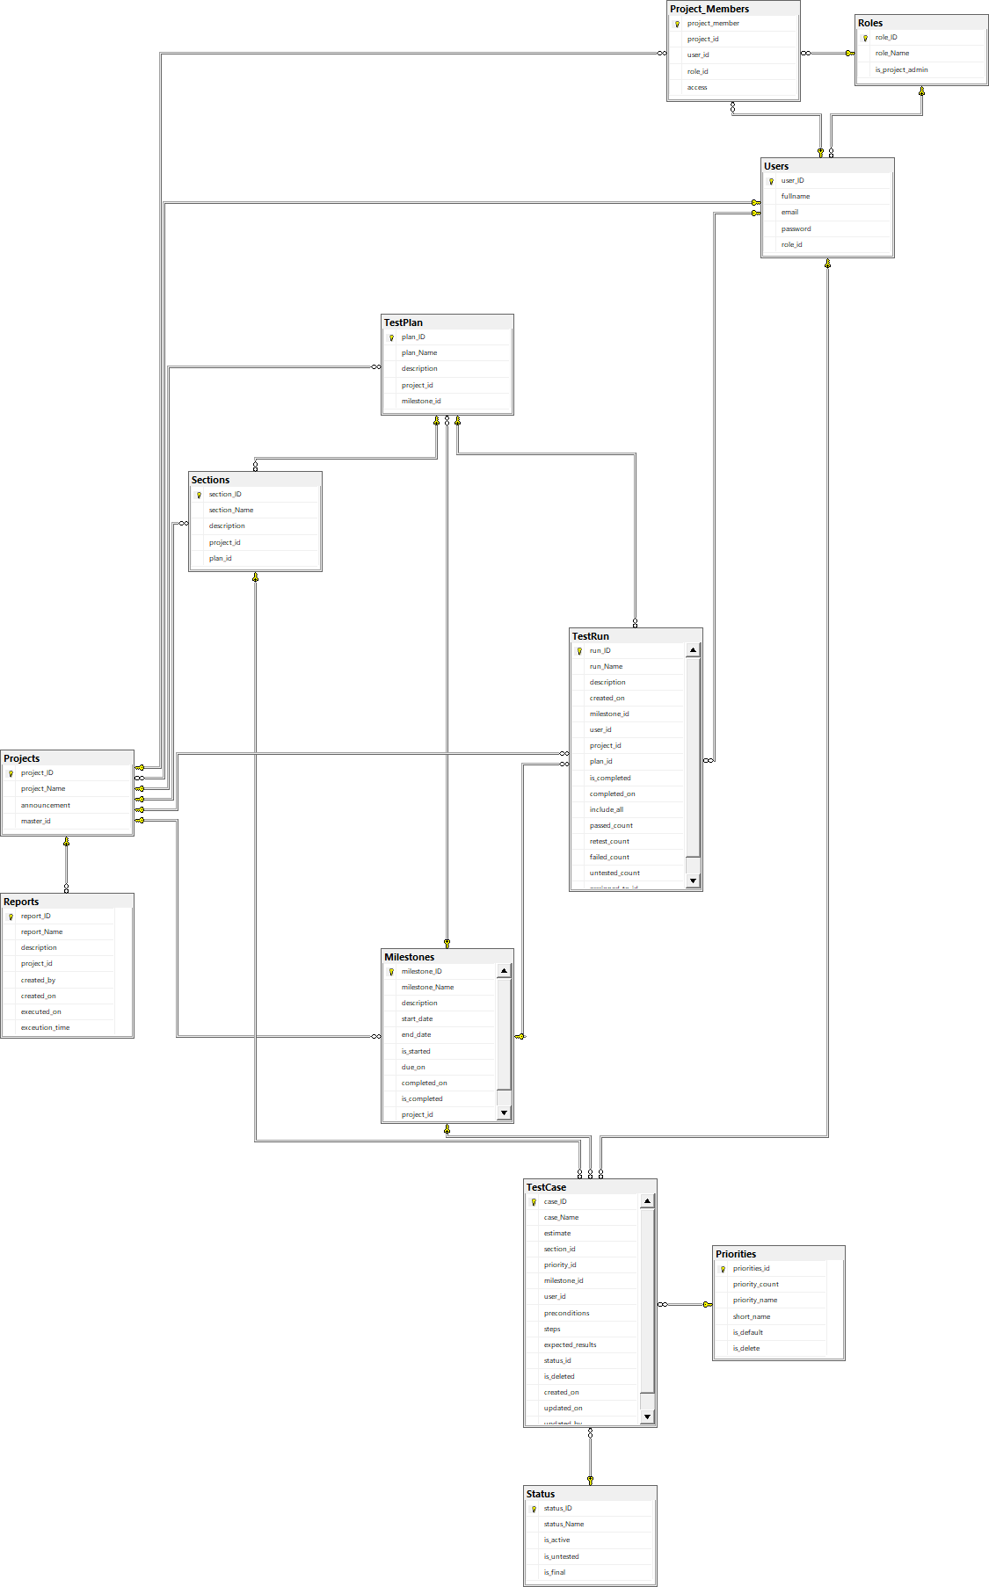

#### a. User

| **Field name** | **Type** | **Size** | **Unique** | **Not Null** | **PK/FK** | **Notes** |
| --- | --- | --- | --- | --- | --- | --- |
| user_id | int |  | X | X | PK |  |
| fullname | nvarchar | 250 |  | X |  |  |
| email | nvarchar | 250 |  | X |  |  |
| password | nvarchar | 250 |  | X |  |  |
| role_id | nvarchar | 250 |  | X | FK |  |

#### b. Role

| **Field name** | **Type** | **Size** | **Unique** | **Not Null** | **PK/FK** | **Notes** |
| --- | --- | --- | --- | --- | --- | --- |
| role_id | int |  | X | X | PK |  |
| role_Name | nvarchar | 250 |  | X |  |  |
| is_project_admin | nt |  |  | X |  |  |

#### c. Project Member

| **Field name** | **Type** | **Size** | **Unique** | **Not Null** | **PK/FK** | **Notes** |
| --- | --- | --- | --- | --- | --- | --- |
| project_member | int |  | X | X |  |  |
| project_id | int |  |  |  | PK |  |
| user_id | int |  |  |  | FK |  |
| role_id | int |  |  |  | FK |  |
| access | nchar | 10 |  |  |  |  |

#### d. Priorities

| **Field name** | **Type** | **Size** | **Unique** | **Not Null** | **PK/FK** | **Notes** |
| --- | --- | --- | --- | --- | --- | --- |
| priorities_id | int |  | X | X | PK |  |
| priority_count | int |  |  | X |  |  |
| priority_name | nvarchar | 250 |  | X |  |  |
| short_name | nvarchar | 250 |  | X |  |  |
| is_default | bit |  |  | X |  |  |
| is_delete | bit |  |  | X |  |  |

#### e. Milestone

| **Field name** | **Type** | **Size** | **Unique** | **Not Null** | **PK/FK** | **Notes** |
| --- | --- | --- | --- | --- | --- | --- |
| milestone_id | int |  | X | X | PK |  |
| milestone_name | nvarchar | 250 |  | X |  |  |
| description | nvarchar | 250 |  | X |  |  |
| start_date | date |  |  |  |  |  |
| end_date | date |  |  |  |  |  |
| is_started | bit |  |  | X |  |  |
| due_on | date |  |  |  |  |  |
| completed_on | date |  |  |  |  |  |
| is_completed | bit |  |  | X |  |  |
| project_id | int |  |  | X | FK |  |

#### f. Reports

| **Field name** | **Type** | **Size** | **Unique** | **Not Null** | **PK/FK** | **Notes** |
| --- | --- | --- | --- | --- | --- | --- |
| report_id | int |  | X | X | PK |  |
| report_Name | nvarchar | 250 |  | X |  |  |
| description | nvarchar | 250 |  |  |  |  |
| project_id | int |  |  | X | FK |  |
| created_by | date |  |  | X |  |  |
| created_on | date |  |  | X |  |  |
| executed_on | date |  |  | X |  |  |
| executed_time | date |  |  | X |  |  |

#### g. Section

| **Field name** | **Type** | **Size** | **Unique** | **Not Null** | **PK/FK** | **Notes** |
| --- | --- | --- | --- | --- | --- | --- |
| section_id | int |  | X | X | PK |  |
| section_name | nvarchar | 250 |  | X |  |  |
| description | nvarchar | 250 |  |  |  |  |
| project_id | int |  |  |  | FK |  |
| plan_id | int |  |  |  | FK |  |

#### h. Test Case

| **Field name** | **Type** | **Size** | **Unique** | **Not Null** | **PK/FK** | **Notes** |
| --- | --- | --- | --- | --- | --- | --- |
| case_id | int |  | X | X | PK |  |
| case_Name | nvarchar |  |  | X |  |  |
| estimate | int |  |  | X |  |  |
| section_id | int |  |  | X | FK |  |
| priority_id | int |  |  | X | FK |  |
| milestone_id | int |  |  |  | FK |  |
| user_id | int |  |  | X | FK |  |
| preconditions | nvarchar | MAX |  |  |  |  |
| steps | nvarchar | MAX |  |  |  |  |
| expected_result | nvarchar | MAX |  |  |  |  |
| status_id | int |  |  |  | FK |  |
| is_deleted | bit |  |  |  |  |  |
| created_on | date |  |  | X |  |  |
| updated_on | date |  |  | X |  |  |
| updated_by | date |  |  | X |  |  |

#### i. Test Run

| **Field name** | **Type** | **Size** | **Unique** | **Not Null** | **PK/FK** | **Notes** |
| --- | --- | --- | --- | --- | --- | --- |
| run_id | int |  | X | X | PK |  |
| run_Name | nvarchar | 250 |  | X |  |  |
| description | nvarchar | 250 |  |  |  |  |
| created_on | date |  |  | X |  |  |
| milestone_id | int |  |  |  | FK |  |
| user_id | int |  |  |  | FK |  |
| project_id | int |  |  |  | FK |  |
| plan_id | int |  |  |  | FK |  |
| is_completed | bit |  |  | X |  |  |
| completed_on | date |  |  | X |  |  |
| include_all | bit |  |  | X |  |  |
| passed_count | int |  |  | X |  |  |
| retest_count | int |  |  | X |  |  |
| failed_count | int |  |  | X |  |  |
| untested_count | int |  |  |  |  |  |
| assigned_to_id | int |  |  |  |  |  |

#### j. Test Plan

| **Field name** | **Type** | **Size** | **Unique** | **Not Null** | **PK/FK** | **Notes** |
| --- | --- | --- | --- | --- | --- | --- |
| plan_id | int |  | X | X | PK |  |
| plan_name | nvarchar | 250 |  | X |  |  |
| description | nvarchar | 250 |  |  |  |  |
| project_id | int |  |  |  | FK |  |
| milestone_id | int |  |  |  | FK |  |

#### k. Status

| **Field name** | **Type** | **Size** | **Unique** | **Not Null** | **PK/FK** | **Notes** |
| --- | --- | --- | --- | --- | --- | --- |
| status_id | int |  | X | X | PK |  |
| status_Name | nvarchar | 250 |  | X |  |  |
| is_active | bit |  |  | X |  |  |
| is_untested | bit |  |  | X |  |  |
| is_final | bit |  |  | X |  |  |

### 4.2 Data File Design

*[File List, in the table format as below]*

| **#** | **File Name** | **Type** | **Notes** |
| --- | --- | --- | --- |
|  | Class name1 |  |  |
|  | Class name2 |  |  |